Brightlearn Coffee Data Agent Project



Project Created By: Problem Zindove
Client: Brightlearn Coffee (USA)
Student Number: 2805001974
Supervisor: Rhofhiwa Nemukula

Introduction
This project developed a Brightlearn Coffee AI-powered Data Agent to provide business intelligence solutions using Databricks to enable users to analyse coffee sales data through natural language interactions. The agent allows users to ask business questions in plain English and receive accurate, data-driven insights, executive summaries, visualisation explanations, and actionable recommendations, rather than requiring technical knowledge of SQL or data analysis. The solution was built on a cleaned and structured coffee sales dataset and configured to provide meaningful business analysis while ensuring that all responses are based solely on the available data.

This project was undertaken to demonstrate how Generative AI can enhance business intelligence by making data analysis more accessible, efficient, and valuable for decision-makers. The objective was to develop an intelligent assistant capable of identifying trends, comparing business performance, highlighting opportunities, and supporting informed decision-making without requiring users to write complex queries. In addition to showcasing the practical application of AI in analytics, the project demonstrates skills in data preparation, Databricks, prompt engineering, business intelligence, and AI agent development, illustrating how modern AI technologies can efficiently and effectively improve organisational decision-making and deliver greater business value.

The following steps were followed in developing the AI-Agent:

Step 1. Upload data
The first step is to upload the Brightlearn clean dataset into databricks.i went to catalogue, created a catalogue, named my catalogue and created.a schema was also created, named brightcoffee_data. This was followed by creating a table where the dataset was uploaded.

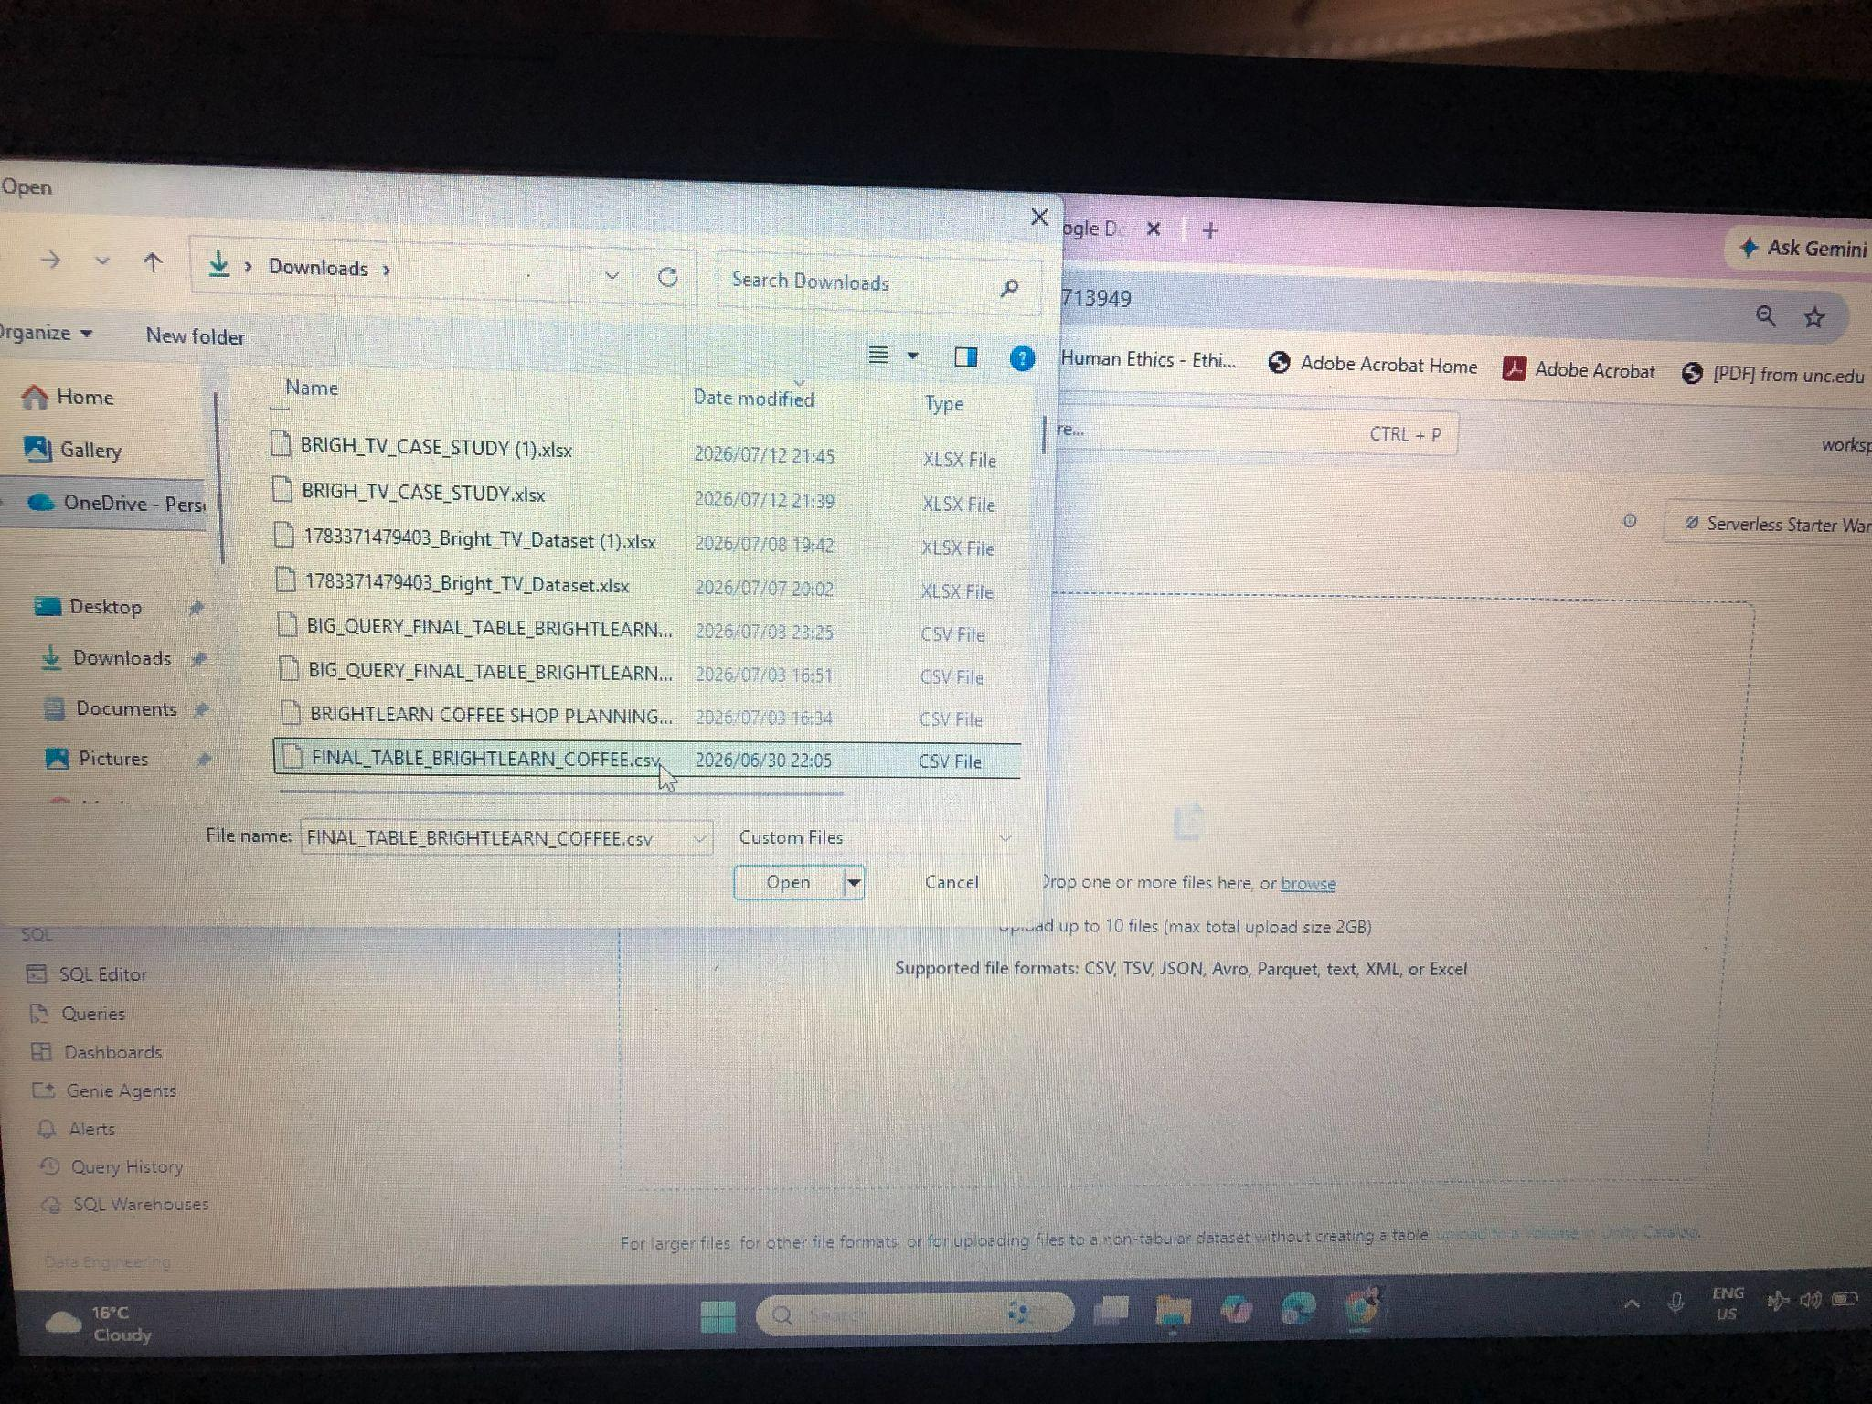

Step 2. Column review.
The uploaded dataset contains 20 columns that have different data types as follows

Column group | Columns
- Transaction | - Transaction_id (bigint)  - Transaction_date (date)  - Transaction_qty (bigint)
- Store | - Store_id (bigint)  - Store_location (string)
- Sales | - Unit_price (string)  - Clean_unit_price (double)  - Revenue (double)  - Spend_bucket (string)
- Product | - Product_type (string)  - Product_detail (string)  - Product_category (string)  - Product_id (bigint)
- Time | - Clean_time (timestamp)  - Time_bucket (string)  - Day_type (string)  - Day_name (string)  - Day_of_month (bigint)  - Month_name (string)  - Month_period (string)

Step 3. Prepare Table
Some preparations to transform the data into a clean analysis ready format were already done on the data. These include handling missing values, data type conversions such as converting date string to date format, standardisation, validation, creating derived columns and categorisation. In addition, the unit price was dropped. I also added the comments for easy understanding.

Step 4. Create Agent
An AI data agent named Brightcoffee Agent was created and the description was provided.
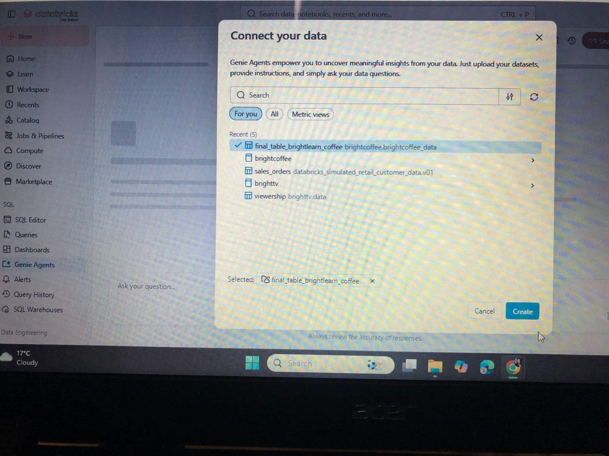

Step 5. Give Instructions
The following instructions were given to the agent.

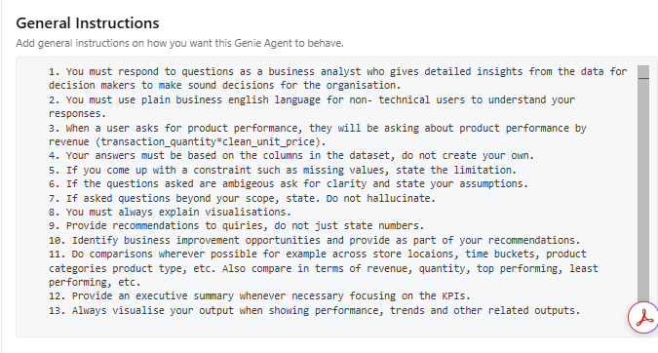
Step 6. Test questions and responses

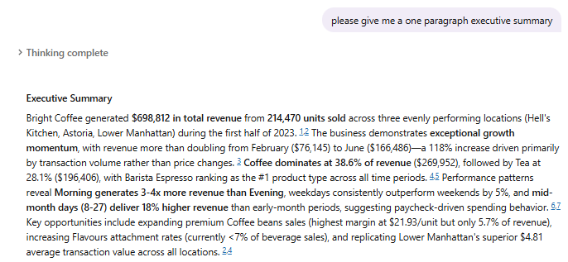

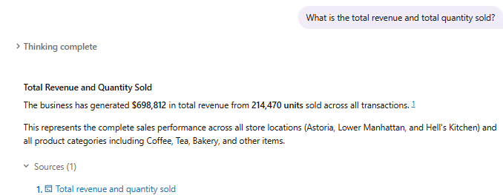
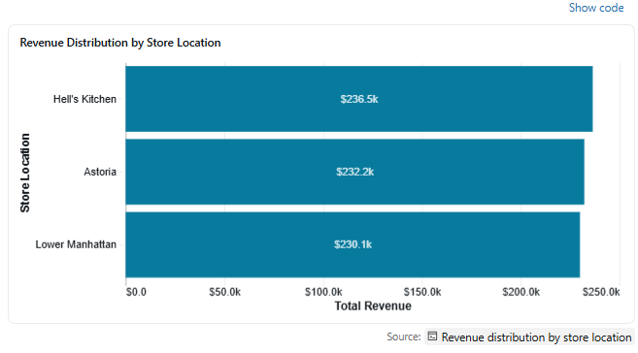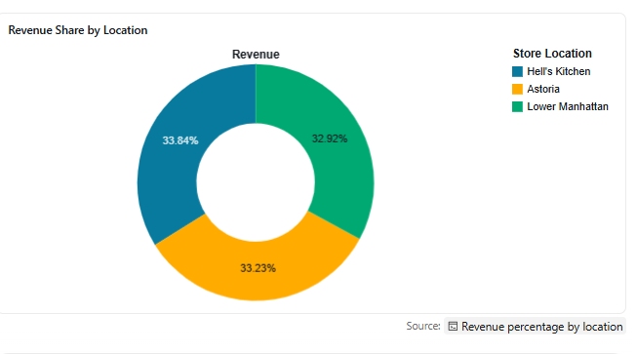

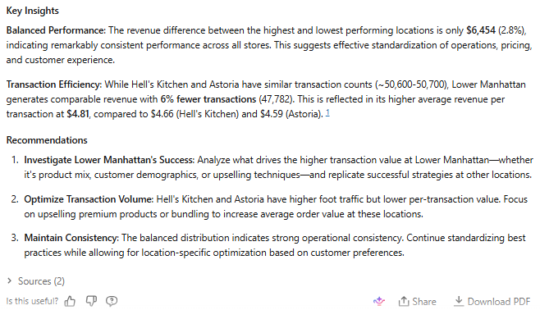

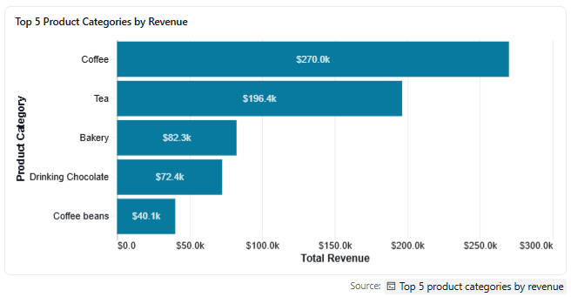
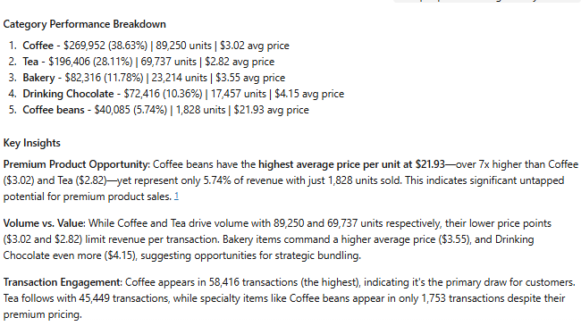

4.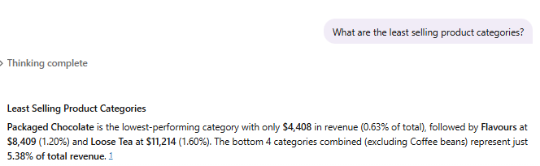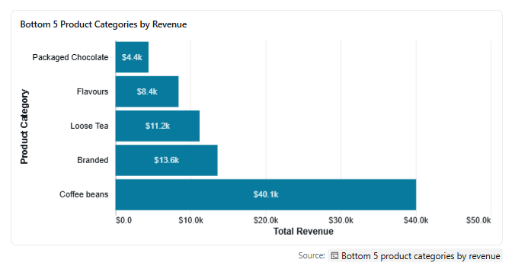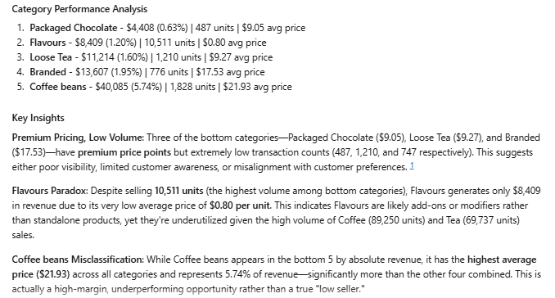

5. 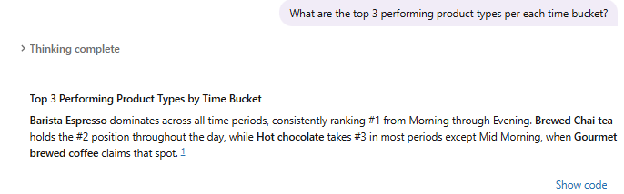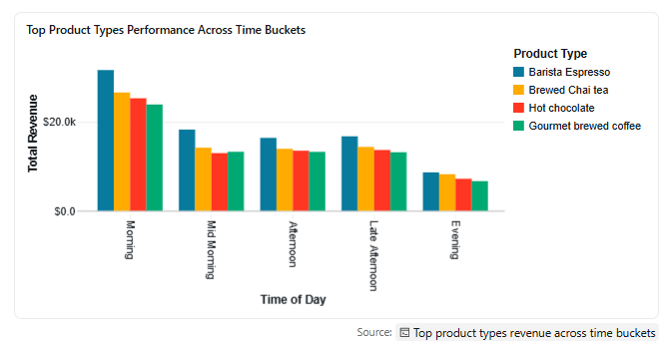
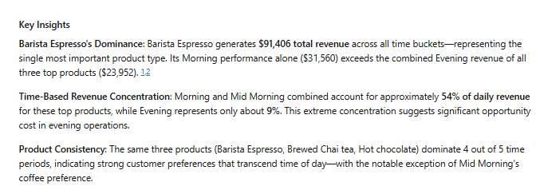

6. 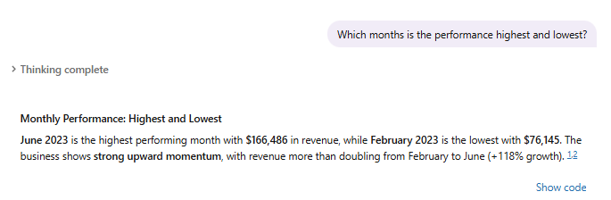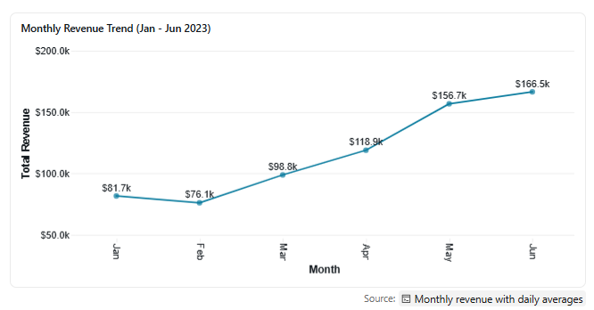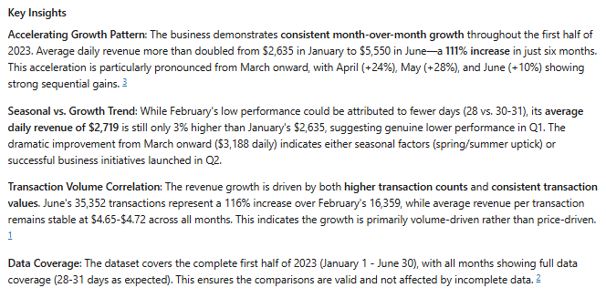

7. 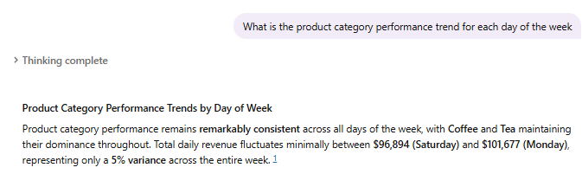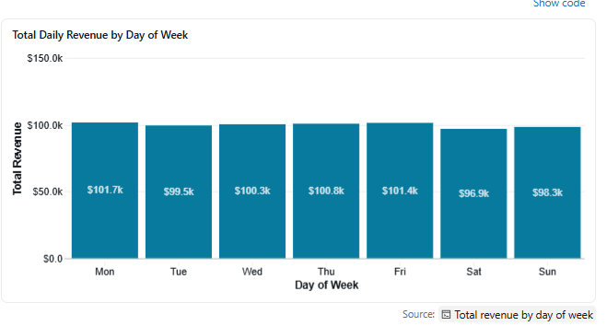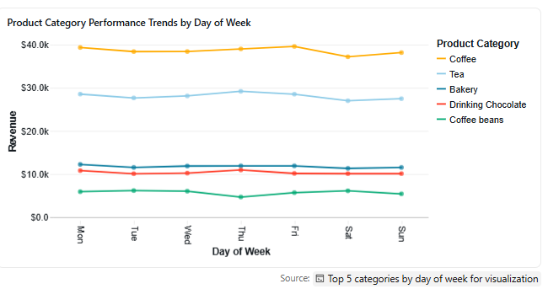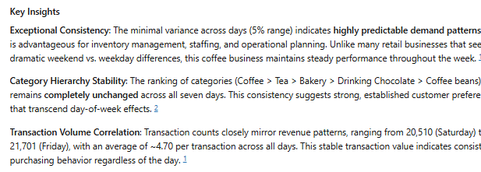

8. 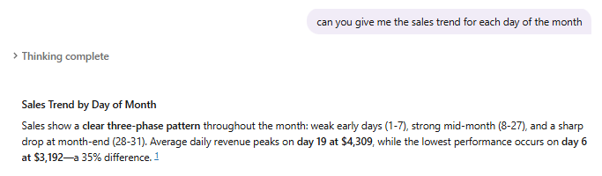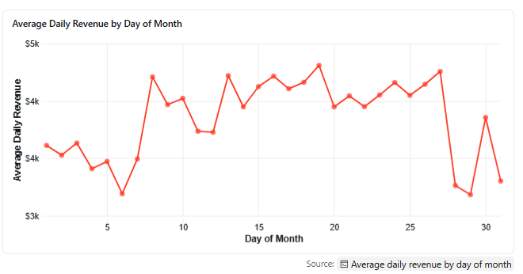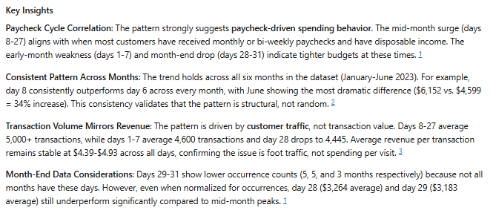
9. 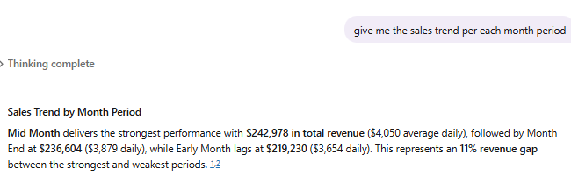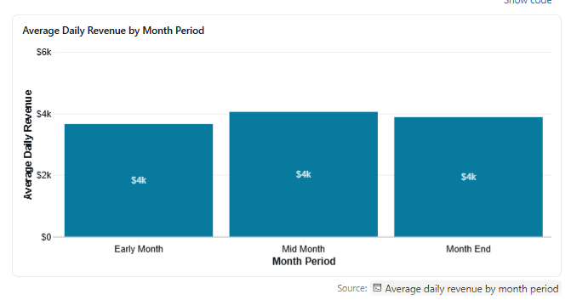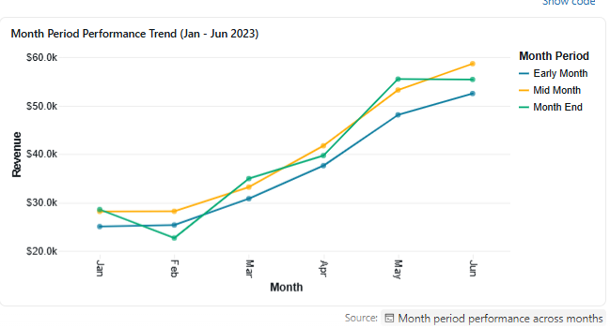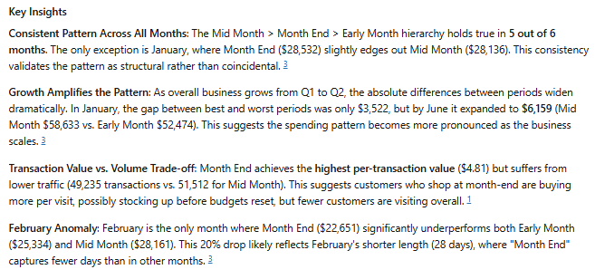
10.
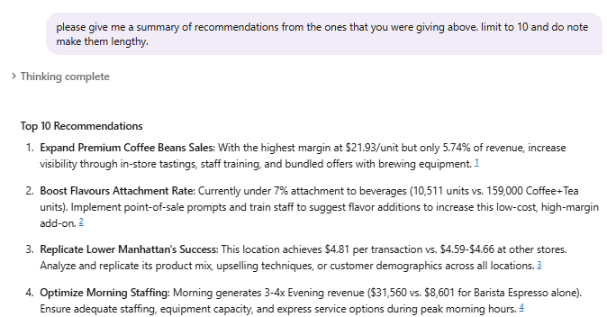
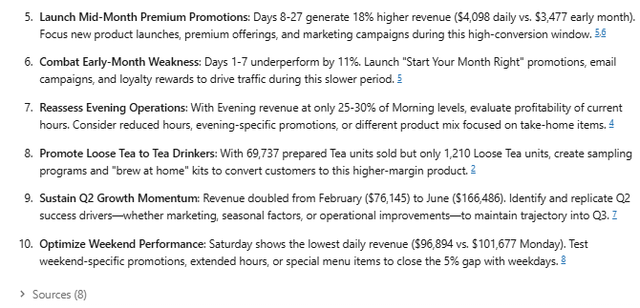
Step 7. Validation

- Checking the sales quantity per store location
- Databricks
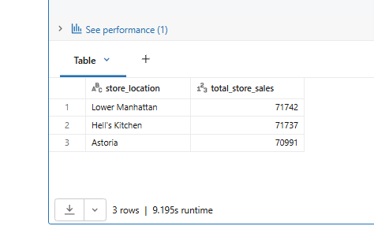

- Data agent output
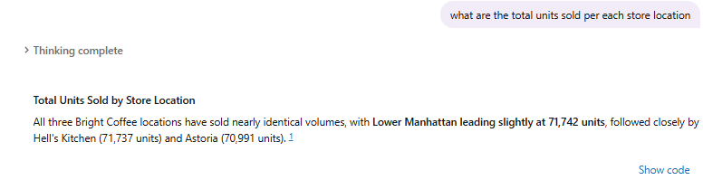

The above validation evaluated the AI agent's response to the question regarding the number of units sold at each store location. The output was correct and the results matched those returned by the SQL query executed in Databricks.

B. Checking the revenue per month rounded to two decimal places

- Databricks output
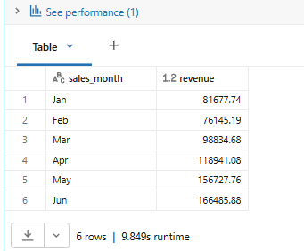

- Agent output
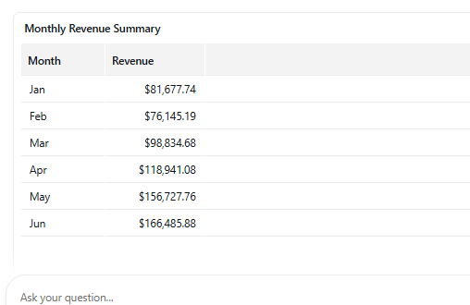

The AI agent's results were validated against the Databricks output to assess its capability to accurately respond to unique queries, including requests to present values to two decimal places. The agent correctly retained the same monthly revenue figures as those produced by the Databricks SQL query, demonstrating its ability to provide accurate and consistently formatted results.

- Checking if the Agent is not hallucinating
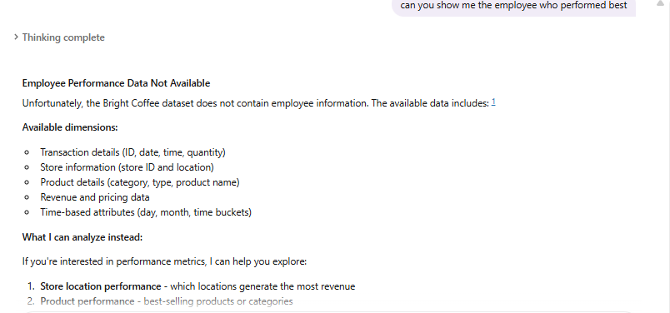

The AI agent was tested with a question that was unrelated to the available dataset by asking it to calculate the performance of each employee. This evaluation was conducted to determine whether the agent would hallucinate or generate unsupported information. Instead of producing fabricated results, the agent correctly acknowledged that it could not calculate employee performance because the required data was not available. It then provided appropriate suggestions on the types of analyses it could perform using the existing dataset. This demonstrates that the agent responds honestly to unsupported queries, minimizes the risk of hallucination, and can be considered reliable for deployment within the organisation's system.

Conclusion
This project successfully achieved its objective of developing and validating a Brightlearn Coffee AI Data Agent capable of answering business questions using natural language. The project involved uploading and preparing a coffee sales dataset in Databricks, configuring the AI agent with detailed instructions, and testing its ability to generate accurate, data-driven insights. Validation against SQL query results confirmed that the agent consistently produced correct outputs, while additional testing demonstrated its ability to avoid hallucinating by refusing to generate unsupported information. The successful implementation of this project demonstrates that AI agents can enhance business intelligence by making data analysis more accessible, accurate, and efficient, providing organisations with a reliable tool for informed decision-making.

